Launch of Web Bhulekh Portal at District Auraiya ,U.P.

New WEB BHULEKH PORTAL has been launched on 2 May 2016 at two tehsils (Auraiya and Bidhuna) at Auraiya District including 8 tehsils of other four districts JP Nagar, Lalitpur, Bijnor and Aligarh. It has been launched in the presence of DIO NIC Auraiya (Mr. Nishant Gupta) and ADIO NIC Auraiya (Ms. Tripti Singh) and DM Auraiya (Smt. Mala Srivastav), SDMs, tehsildars , R.K. and Lekhpal of respective tehsils . On 27 November 2014, one project team had been formed under the valuable guidance of SIO, UP Dr. Saurabh Gupta and Shri G.P. Singh (ASIO) including team members Shri R.K.Gangal, Shri Vinay Dixit, Shri Ashish Rastogi and Shri Rajesh Tripathi and members from all 5 districts.

Ms. Tripti Singh (STA-A) ADIO, NIC Auraiya was one of the team member of this Bhulekh Project Team under the district leadership of Mr. Nishant Gupta, DIO NIC from Auraiya District. For the first time in the country, a web based online system was developed & implemented for land records as it contains very sensitive information which is land records of farmers. In offline module ISFOC tables were used. To make ISFOC to UNICODE utility was a big task. Because of sensitive data shifting of data without losing its consistency to new Bhulekh portal was a challenge. After rigorous testing at district level and with the help of efficient development team at state HQ, An effective web bhulekh portal has come out as a result.

Previously farmers of the district have to wait atleast for one month (due to offline data uploading happens at the last of month) to get ‘Khatauni and Intekabh’ but new WEB BHULEKH PORTAL (Website: upbhulekh.gov.in) is online now. Farmers can see their digitally signed ‘Khatauni and Intekabh’ immediately after it has been entered in the portal at anywhere. Now farmers should not wait for offline data uploading to see the orders of court for their land and it will increase the transparency as well as trust of public at bhulekh centers because bhulekh employee cannot enter the court order of previous dates. Farmers can get digitally signed ‘Khatauni and Intekabh’ from any CSC center immediately.

In the portal four types of user has been made having different access level:
- Admin User
- Conversion and Upload User
- Mutation User
- Report User
which will increase the accountability and will divide the responsibility of the tehsil’s employees accordingly.

After continuous hard work and strong commitment of the Bhulekh team (State project team and NIC officers of all 5 districts) WEB BHULEKH PORTAL has launched in pilot districts and results as a tremendous success in Uttar Pradesh state.

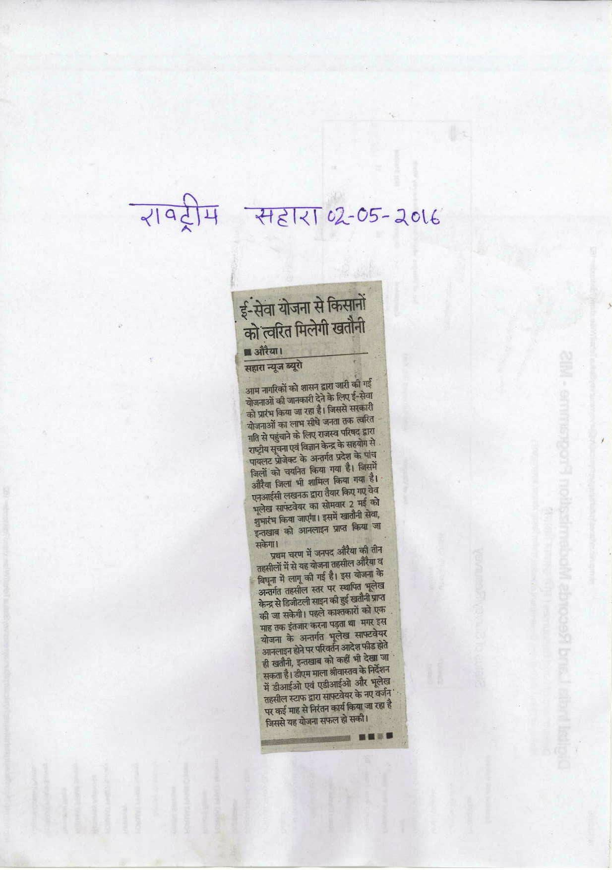
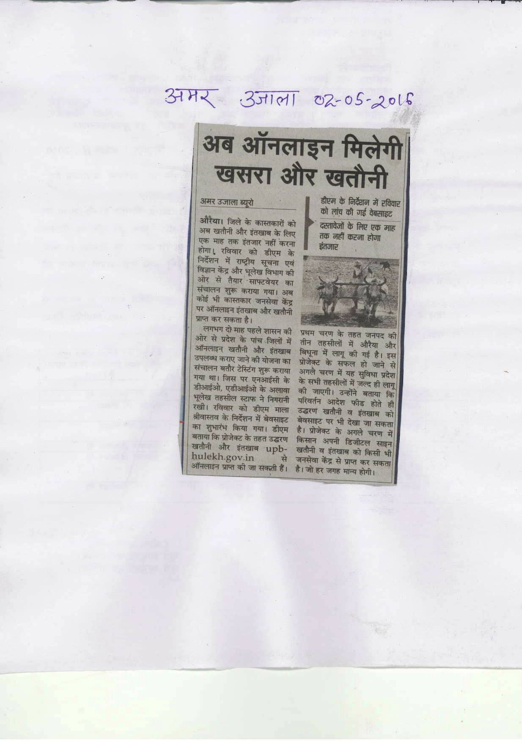

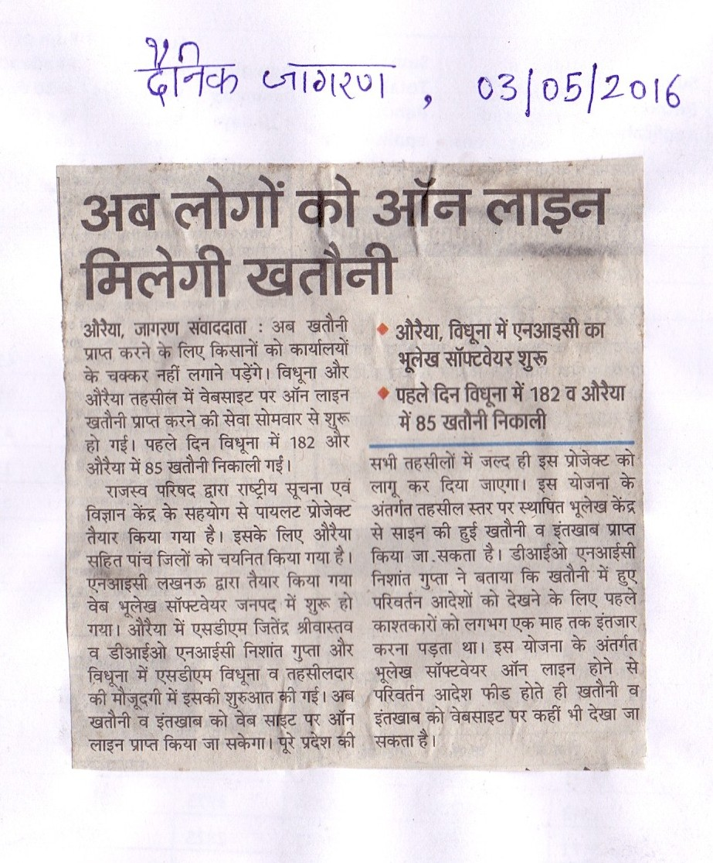

With Regards,
NIC Auraiya
District Unit
Uttar Pradesh

